ProjectDesignPhase-2

Data FlowDiagram&UserStories

|  |  |
| --- | --- |
| TeamID | PNT2022TMID51290 |
| ProjectName | IOTBasedSmallCropProtectionSystemForAgriculture |

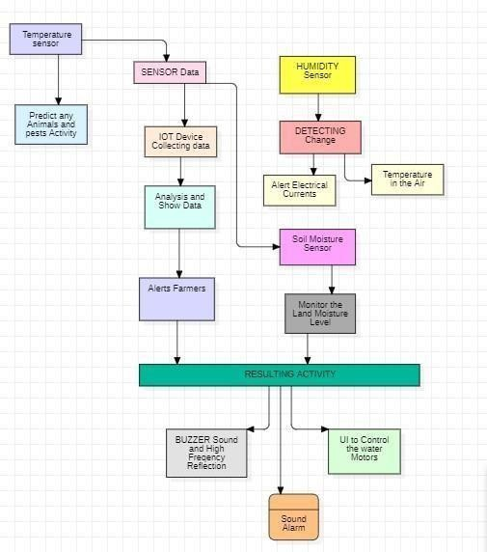

|  |  |  |  |  |  |  |
| --- | --- | --- | --- | --- | --- | --- |
| UserType | Functionalrequirement (Epic) | UserStorynumber | UserStory/Task | Acceptancecriteria | Priority | Release |
| Customer(Mobileuser) | Registration | USN-1 | Usercanenterintothewebapplication | I can accessmyaccount  /dashboard | High | Sprint1 |
|  |  | USN-2 | User can register theircredentialslikeemailidandpassword | I can receiveconfirmationemail &clickconfirm | High | Sprint1 |
|  | Login | USN-3 | User can log into theapplicationyenteringemailandpassword | Icanlogintomyaccount | High | Sprint1 |
|  | Dashboard | USN-4 | UsercanViewthetemperature | I can view thedata given bythedevice | High | Sprint2 |
|  |  | USN-5 | Usercanviewthelevel ofsensormonitoringvalue | I can view thedata given bythe  device | High | Sprint2 |
| Customer(Webuser) | Usage | USN-1 | Usercanviewthewebpage and get theinformaton | I can view thedata given bythedevice | High | Sprint3 |
| customer | Working | USN-1 | Useractaccordingtothealert givenbythedevice | Icangetthedata workaccordingto  it | High | Sprint3 |

|  |  |  |  |  |  |  |
| --- | --- | --- | --- | --- | --- | --- |
|  |  | USN-2 | UserturnsONthewatermotors/Buzzer/SoundAlarm when occur thedisturbanceonfield | Icangetthedata workaccordingto  it |  | Sprint4 |
| CustomercareExecutive | Action | USN-1 | Usersolvetheproblemwhen some faces anyusageissues | I Can solve theissues  when someone fails tounderstanding theprocedure | High | Sprint4 |
| Administration | Administration | USN-1 | Usestoreeveryinformation | ICanstorethegainedinformation | High | Sprint4 |